**1.INTRODUCTION**

**1.1 OVERVIEW**

The goal of this project is to predict student adaptability level in Online Education. That is, given historical information about past online education system can we use machine learning to estimate for the future campaigns.  
Machine learning can play a significant role in improving the effectiveness of customer acquisition strategies by accurately predicting the cost of acquiring customers. With the right data and machine learning algorithms, businesses can optimize their education online, allocate resources more efficiently, and ultimately increase their return on investment. Our aim is to develop a robust and accurate  prediction model that can help businesses make informed decisions about their customer acquisition strategies.

**1.2 PURPOSE**

* **Enhancing Student Success:** Students who can adapt to online learning are more likely to succeed in their courses. By identifying and supporting students with lower adaptability levels, educators can help them overcome challenges and achieve their academic goals.
* **Resource Allocation:** Institutions can allocate resources more efficiently by identifying which students may require additional support, such as tutoring, technical assistance, or study skills training.
* **Retention and Graduation Rates:** Improving student adaptability in online education can positively impact retention and graduation rates, as students who are better equipped to navigate the online learning environment are more likely to stay enrolled and complete their degrees.
* **Personalized Support:** Knowing a student's adaptability level can inform the design of personalized learning plans or interventions. For instance, if a student struggles with time management in an online course, they can receive targeted support to improve this skill.
* **Feedback and Continuous Improvement:** Institutions can use data on student adaptability levels to make improvements in their online course offerings, platforms, and instructional strategies. By understanding where students struggle, educators can make necessary adjustments.
* **Preparation for Future Learning:** In an increasingly digital world, adaptability in online learning is a valuable skill. Assessing and developing this skill can help students prepare for lifelong learning, as they are likely to encounter online education and training throughout their careers.

**2.LITERATURE SURVEY**

**2.1 EXISTING PROBLEM**

* **Digital Literacy and Technical Issues:** Many students, particularly those from underserved communities, may lack the necessary digital literacy skills to navigate online platforms effectively. Technical issues such as poor internet connectivity or device limitations can also hinder their adaptability.
* **Self-Motivation and Time Management:** Online education often requires a higher degree of self-motivation and time management compared to traditional classroom settings
* **Isolation and Lack of Engagement:** Online learning can be isolating, as students may miss out on the social interactions and in-person engagement that come with traditional classrooms. This isolation can impact motivation and mental health.
* **Different Learning Styles:** Online education may not suit all learning styles. Some students thrive in interactive, hands-on learning environments and may struggle with passive online lectures or reading-intensive courses.
* **Access to Resources:** Not all students have equal access to the necessary resources for online learning, such as a quiet study space, reliable internet, or up-to-date devices. This digital divide can exacerbate existing inequalities in education.
* **Assessment and Cheating:** Ensuring academic integrity in online assessments can be challenging, leading to concerns about cheating and plagiarism. This can affect the quality of education and the validity of students' achievements.

**2.2 PROPOSED SOLUTION**

* **Digital Literacy Training:**
* Implement digital literacy programs to teach students essential skills for navigating online platforms, using digital tools, and troubleshooting technical issues.
* Offer tutorials and resources to help students become proficient with online learning technologies.
* **Mentorship and Support:**
* Establish mentorship programs where experienced online learners or peers can guide and support new students in adapting to the online learning environment.
* Provide access to dedicated support services for technical assistance and academic support.
* **Time Management and Study Skills:**
* Offer time management workshops and resources to help students develop effective study habits and organization skills.
* **Social Interaction:**
* Create virtual spaces for students to connect and collaborate, fostering a sense of community within the online learning environment.
* Organize virtual events, discussion forums, and peer study groups to encourage social interaction.
* **Access to Resources:**.
* Establish on-campus or community-based study centers for students without suitable study environments at home.

.

* **Continuous Evaluation and Improvement:**
* Regularly collect feedback from students about their online learning experiences and use this feedback to make continuous improvements to courses and support services.

**3.THEORITICAL ANALYSIS**

**3.1 Block diagram**



**3.2 Hardware/software designing**

**Hardware requirements**

1.computer server:

you will need a computer or server with suffient processing power to train and run ml models

2.memory(RAM)

the amount of RAM you need depends on the size of your dataset and the compelxity of your models

3.storage:

you'll need enough storage space to store your datasets,model weights,and any other project-related files,SSDs(solid state drives) are recommended for faster data access

4.internet connection

a reliable internet connection is essiential for downloading libraries ,updates and accessing cloud-based services if needed

**Software requirements**

python,anaconda,visual studio code,

**4 .EXPERIMENTAL INVESTIGATIONS**

**Experimental Investigation Steps:**

Research Question and Hypotheses: Clearly define your research question and hypotheses related to student adaptability levels in online education. For example, you might investigate whether a specific teaching approach improves student adaptability.

Literature Review: Conduct a thorough literature review to understand existing research on online education and student adaptability. This will help you identify gaps in the literature that your experiment can address.

Experimental Design: Design your experiment, including the selection of participants, the online learning environment, and any interventions or treatments you plan to implement.

Data Collection: Collect data using appropriate methods, such as surveys, observations, or pre- and post-tests. Ensure that your data collection instruments are reliable and valid.

Data Analysis: Analyze the data using statistical techniques relevant to your research question. This could involve descriptive statistics, inferential statistics, or qualitative analysis, depending on your study design.

Discussion and Conclusion: Interpret the results of your experiment and discuss their implications for student adaptability in online education. Be sure to address the limitations of your study.

Write a Report or Paper: Document your research in a formal report or paper following the appropriate academic format and citation style.

**5.FLOWCHART**

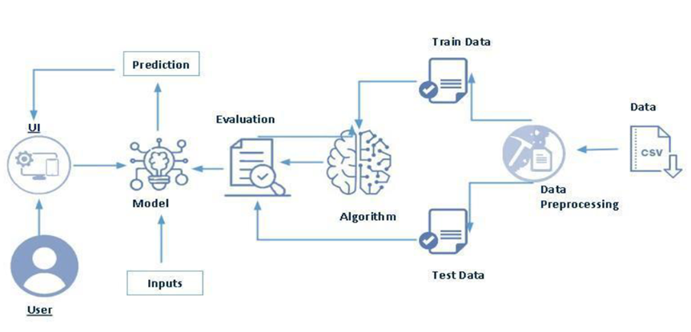

**6.RESULT**

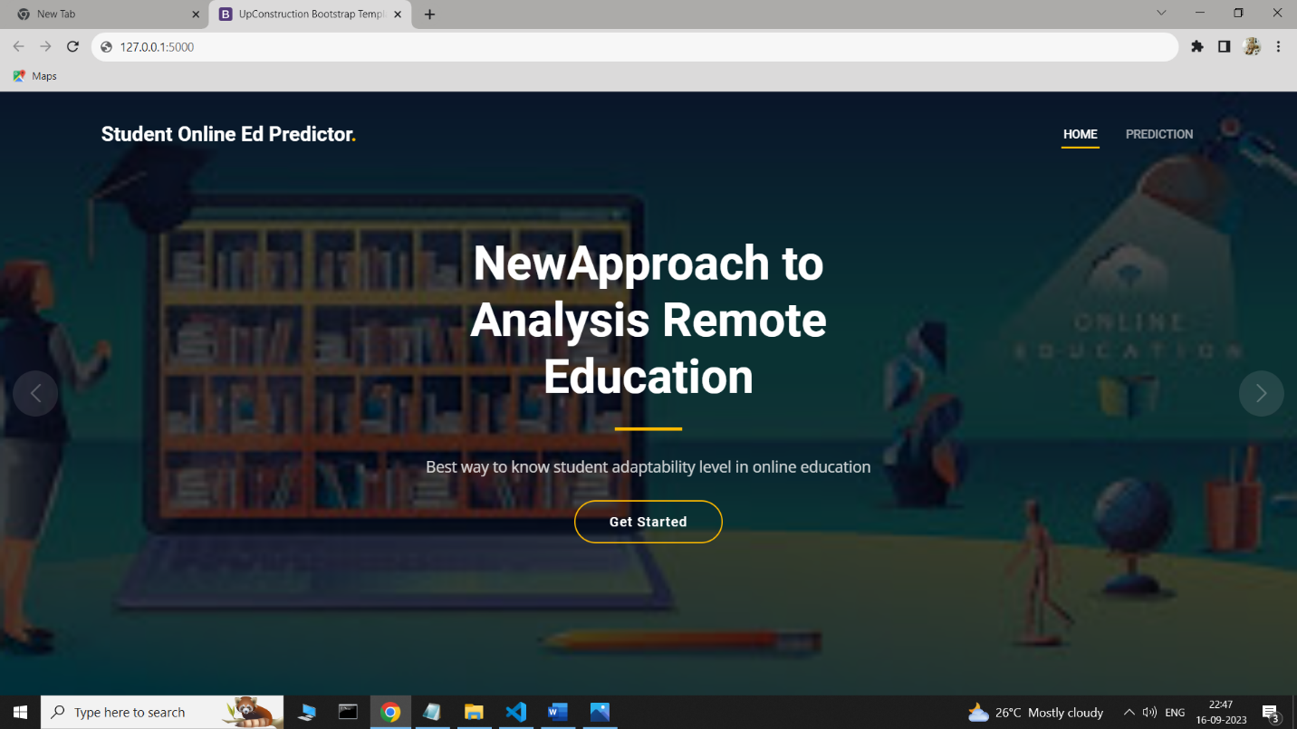

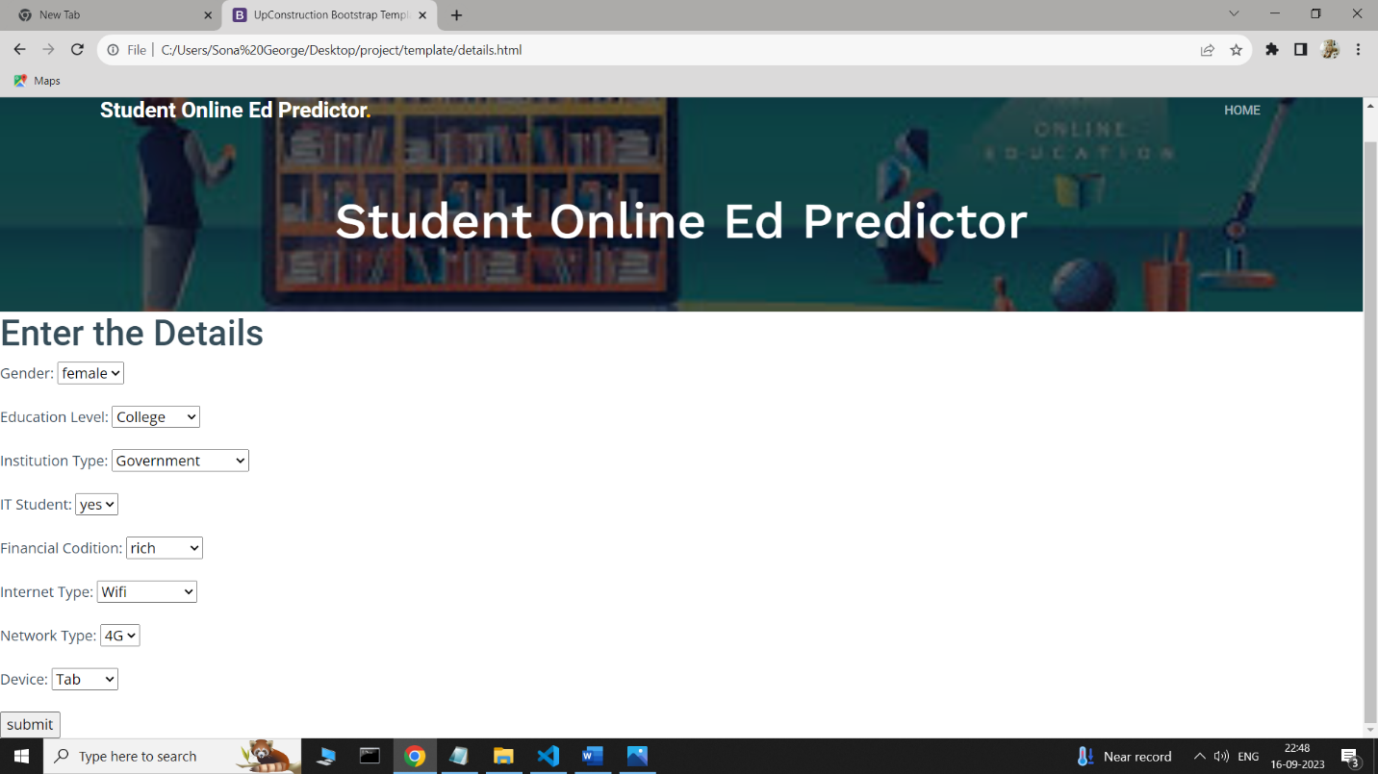

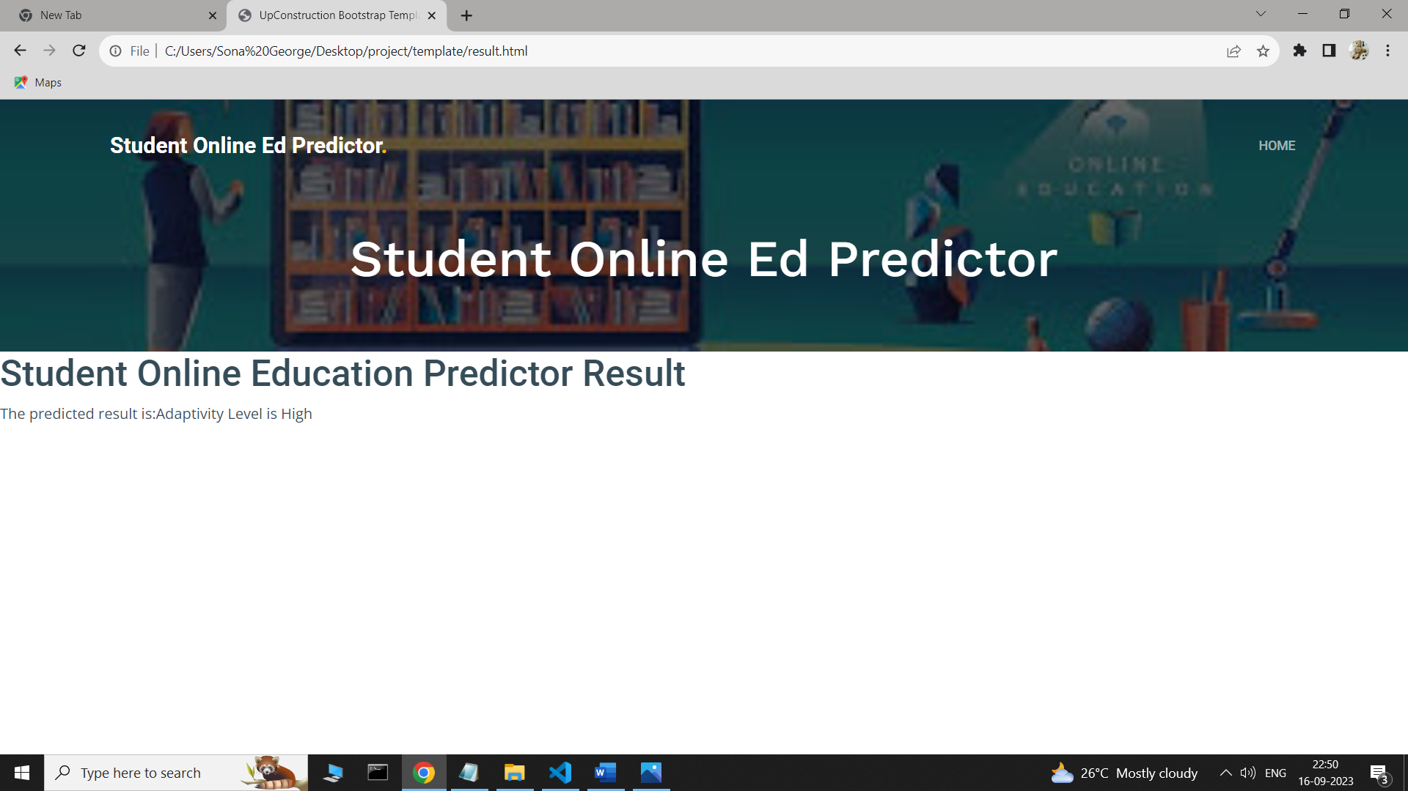

**7 ADVANTAGES & DISADVANTAGES**

**Advantages:**

**Flexibility**: Online education offers flexibility in terms of when and where students can learn. This flexibility can accommodate various schedules and learning preferences, allowing students to adapt their learning to their individual needs.

**Access to Diverse Resources:** Online learning provides access to a wide range of digital resources, including multimedia content, e-books, and interactive simulations, which can enhance the learning experience.

**Self-Paced Learning**: Students can progress at their own pace, allowing for a more personalized learning experience. They can review materials as needed and spend more time on challenging concepts.

**Cost Savings**: Online education often eliminates the need for commuting and housing expenses, making it a more cost-effective option for many students.

**Global Reach**: Students can enroll in courses offered by institutions worldwide, expanding their opportunities to learn from experts and collaborate with peers from different cultural backgrounds.

**Skill Development**: Online education fosters digital literacy, time management, and self-discipline skills, which are valuable in today's technology-driven world.

**Disadvantages**:

**Digital Divide**: Not all students have access to the necessary technology and high-speed internet required for online learning, creating inequalities in access and opportunities.

**Isolation**: Online learning can be isolating, leading to a lack of social interaction and a sense of disconnect from peers and instructors. Loneliness and reduced motivation can result.

**Lack of Hands-On Experience**: Some fields, such as science and engineering, require hands-on laboratory or practical experience that is challenging to replicate online.

**Technical Issues:** Technical problems, such as system glitches or connectivity issues, can disrupt the learning process and cause frustration for students.

**Self-Motivation and Discipline**: Online learners must be self-motivated and disciplined to stay on track with their studies. Procrastination and distractions at home can impede progress.

.**8 APPLICATIONS**

**Admission and Placement**: Institutions can use adaptability assessments to determine whether a student is well-suited for online education. This information can help with admission decisions and appropriate course placement.

**Course Design and Curriculum Development**: Understanding student adaptability levels can inform the design of online courses. Educators can tailor course materials, assignments, and assessments to better match the adaptability levels of their students, making the learning experience more effective.

**Personalized Learning:** Adaptive learning systems can use adaptability data to provide personalized learning paths for students. This ensures that each student receives content and assignments aligned with their adaptability and skill level.

**Intervention and Support:** Institutions can use adaptability assessments to identify students who may be struggling to adapt to the online environment. This early identification allows for targeted interventions and support services to help those students succeed.

**Resource Allocation**: Adaptability data can inform resource allocation decisions. Institutions can allocate resources such as technical support, tutoring, and mental health services based on the specific needs of students with varying adaptability levels

**Retention and Graduation Initiatives**: Institutions can develop retention programs that focus on improving the adaptability of at-risk students. This can help improve graduation rates by addressing adaptability-related challenges.

**Instructor Training:** Institutions can provide training for instructors on how to recognize and address adaptability issues in their students. This training can lead to better online teaching practices and improved student outcomes.

**Research and Policy Development**: Educational researchers can use adaptability data to study trends and correlations related to student success in online education. This research can inform policy development and best practices in online learning.

**CONCLUSION**

In conclusion, assessing and addressing student adaptability levels in online education is crucial for the success of both individual learners and educational institutions. Online education offers numerous benefits, including flexibility and access to diverse resources, but it also presents challenges related to digital literacy, motivation, and social interaction.

**FUTURE SCOPE**

**Advanced Adaptive Learning Technologies:** The development of more sophisticated adaptive learning platforms will become increasingly common. These platforms will use AI and machine learning to tailor educational content and experiences to individual student adaptability levels in real-time.

**Virtual Reality (VR) and Augmented Reality (AR):** VR and AR technologies will be integrated more extensively into online education, providing immersive and interactive learning experiences. These technologies have the potential to improve engagement and adaptability.

**Gamification and Microlearning:** Gamification elements and microlearning modules will become integral components of online courses. Gamified activities can enhance motivation and adaptability by making learning more engaging.

**Digital Credentialing**: Digital credentials, such as microdegrees and badges, will gain prominence. These credentials can help students adapt to the evolving job market and demonstrate their adaptability and skills to potential employers.

**Neuroscience and Cognitive Psychology Insights**: A deeper understanding of how students learn and adapt in online environments, informed by neuroscience and cognitive psychology research, will inform the design of more effective online courses and interventions.

**Global Learning Communities**: Online education will continue to foster global learning communities, allowing students to collaborate with peers from diverse backgrounds and adapt to a globalized world.

**BIBILOGRAPHY**

Anderson, T., & Dron, J. (2011). Three generations of distance education pedagogy. The International Review of Research in Open and Distributed Learning, 12(3), 80-97.

Hrastinski, S. (2008). Asynchronous and synchronous e-learning. Educause Quarterly, 31(4), 51-55.

Means, B., Toyama, Y., Murphy, R., Bakia, M., & Jones, K. (2010). Evaluation of evidence-based practices in online learning: A meta-analysis and review of online learning studies. US Department of Education.

Picciano, A. G. (2017). Theories and frameworks for online education: Seeking an integrated model. Online Learning, 21(3), 166-190.

Siemens, G. (2005). Connectivism: A learning theory for the digital age. International Journal of Instructional Technology and Distance Learning, 2(1), 3-10.

Song, L., Singleton, E. S., Hill, J. R., & Koh, M. H. (2004). Improving online learning: Student perceptions of useful and challenging characteristics. The Internet and Higher Education, 7(1), 59-70**.**

**APPENDIX**

**1.SOURCE CODE**

**Index1.html**

<!DOCTYPE html>

<html lang="en">

<head>

<meta charset="utf-8">

<meta content="width=device-width, initial-scale=1.0" name="viewport">

<title>UpConstruction Bootstrap Template - Index</title>

<meta content="" name="description">

<meta content="" name="keywords">

<!-- Favicons -->

<link href="assets/img/favicon.png" rel="icon">

<link href="assets/img/apple-touch-icon.png" rel="apple-touch-icon">

<!-- Google Fonts -->

<link rel="preconnect" href="https://fonts.googleapis.com">

<link rel="preconnect" href="https://fonts.gstatic.com" crossorigin>

<link href="https://fonts.googleapis.com/css2?family=Open+Sans:ital,wght@0,300;0,400;0,500;0,600;0,700;1,300;1,400;1,600;1,700&family=Roboto:ital,wght@0,300;0,400;0,500;0,600;0,700;1,300;1,400;1,500;1,600;1,700&family=Work+Sans:ital,wght@0,300;0,400;0,500;0,600;0,700;1,300;1,400;1,500;1,600;1,700&display=swap" rel="stylesheet">

<!-- Vendor CSS Files -->

<link href="assets/vendor/bootstrap/css/bootstrap.min.css" rel="stylesheet">

<link href="assets/vendor/bootstrap-icons/bootstrap-icons.css" rel="stylesheet">

<link href="assets/vendor/fontawesome-free/css/all.min.css" rel="stylesheet">

<link href="assets/vendor/aos/aos.css" rel="stylesheet">

<link href="assets/vendor/glightbox/css/glightbox.min.css" rel="stylesheet">

<link href="assets/vendor/swiper/swiper-bundle.min.css" rel="stylesheet">

<!-- Template Main CSS File -->

<link href="assets/css/main.css" rel="stylesheet">

<!-- =======================================================

* Template Name: UpConstruction

* Updated: Aug 30 2023 with Bootstrap v5.3.1

* Template URL: https://bootstrapmade.com/upconstruction-bootstrap-construction-website-template/

* Author: BootstrapMade.com

* License: https://bootstrapmade.com/license/

======================================================== -->

</head>

<body>

<!-- ======= Header ======= -->

<header id="header" class="header d-flex align-items-center">

<div class="container-fluid container-xl d-flex align-items-center justify-content-between">

<a href="index1.html" class="logo d-flex align-items-center">

<!-- Uncomment the line below if you also wish to use an image logo -->

<!-- <img src="assets/img/logo.png" alt=""> -->

<h1>Student Online Ed Predictor<span>.</span></h1>

</a>

<i class="mobile-nav-toggle mobile-nav-show bi bi-list"></i>

<i class="mobile-nav-toggle mobile-nav-hide d-none bi bi-x"></i>

<nav id="navbar" class="navbar">

<ul>

<li><a href="index1.html" class="active">Home</a></li>

<li><a href="details.html">Prediction</a></li>

</ul>

</nav><!-- .navbar -->

</div>

</header><!-- End Header -->

<!-- ======= Hero Section ======= -->

<section id="hero" class="hero">

<div class="info d-flex align-items-center">

<div class="container">

<div class="row justify-content-center">

<div class="col-lg-6 text-center">

<h2 data-aos="fade-down">New<span>Approach to Analysis Remote Education</span></h2>

<p data-aos="fade-up">Best way to know student adaptability level in online education</p>

<a data-aos="fade-up" data-aos-delay="200" href="#get-started" class="btn-get-started">Get Started</a>

</div>

</div>

</div>

</div>

<div id="hero-carousel" class="carousel slide" data-bs-ride="carousel" data-bs-interval="5000">

<div class="carousel-item active" style="background-image: url(assets/img/images.jpg)"></div>

<a class="carousel-control-prev" href="#hero-carousel" role="button" data-bs-slide="prev">

<span class="carousel-control-prev-icon bi bi-chevron-left" aria-hidden="true"></span>

</a>

<a class="carousel-control-next" href="#hero-carousel" role="button" data-bs-slide="next">

<span class="carousel-control-next-icon bi bi-chevron-right" aria-hidden="true"></span>

</a>

</div>

</section><!-- End Hero Section -->

<a href="#" class="scroll-top d-flex align-items-center justify-content-center"><i class="bi bi-arrow-up-short"></i></a>

<div id="preloader"></div>

<script src="assets/vendor/bootstrap/js/bootstrap.bundle.min.js"></script>

<script src="assets/vendor/aos/aos.js"></script>

<script src="assets/vendor/glightbox/js/glightbox.min.js"></script>

<script src="assets/vendor/isotope-layout/isotope.pkgd.min.js"></script>

<script src="assets/vendor/swiper/swiper-bundle.min.js"></script>

<script src="assets/vendor/purecounter/purecounter_vanilla.js"></script>

<script src="assets/vendor/php-email-form/validate.js"></script>

<script src="assets/js/main.js"></script>

</body>

</html>

**Details.html**

<!DOCTYPE html>

<html lang="en">

<head>

<meta charset="utf-8">

<meta content="width=device-width, initial-scale=1.0" name="viewport">

<title>UpConstruction Bootstrap Template - Contact</title>

<meta content="" name="description">

<meta content="" name="keywords">

<!-- Favicons -->

<link href="assets/img/favicon.png" rel="icon">

<link href="assets/img/apple-touch-icon.png" rel="apple-touch-icon">

<!-- Google Fonts -->

<link rel="preconnect" href="https://fonts.googleapis.com">

<link rel="preconnect" href="https://fonts.gstatic.com" crossorigin>

<link href="https://fonts.googleapis.com/css2?family=Open+Sans:ital,wght@0,300;0,400;0,500;0,600;0,700;1,300;1,400;1,600;1,700&family=Roboto:ital,wght@0,300;0,400;0,500;0,600;0,700;1,300;1,400;1,500;1,600;1,700&family=Work+Sans:ital,wght@0,300;0,400;0,500;0,600;0,700;1,300;1,400;1,500;1,600;1,700&display=swap" rel="stylesheet">

<!-- Vendor CSS Files -->

<link href="assets/vendor/bootstrap/css/bootstrap.min.css" rel="stylesheet">

<link href="assets/vendor/bootstrap-icons/bootstrap-icons.css" rel="stylesheet">

<link href="assets/vendor/fontawesome-free/css/all.min.css" rel="stylesheet">

<link href="assets/vendor/aos/aos.css" rel="stylesheet">

<link href="assets/vendor/glightbox/css/glightbox.min.css" rel="stylesheet">

<link href="assets/vendor/swiper/swiper-bundle.min.css" rel="stylesheet">

<!-- Template Main CSS File -->

<link href="assets/css/main.css" rel="stylesheet">

<!-- =======================================================

* Template Name: UpConstruction

* Updated: Aug 30 2023 with Bootstrap v5.3.1

* Template URL: https://bootstrapmade.com/upconstruction-bootstrap-construction-website-template/

* Author: BootstrapMade.com

* License: https://bootstrapmade.com/license/

======================================================== -->

</head>

<body>

<!-- ======= Header ======= -->

<header id="header" class="header d-flex align-items-center">

<div class="container-fluid container-xl d-flex align-items-center justify-content-between">

<a href="index1.html" class="logo d-flex align-items-center">

<!-- Uncomment the line below if you also wish to use an image logo -->

<!-- <img src="assets/img/logo.png" alt=""> -->

<h1>Student Online Ed Predictor<span>.</span></h1>

</a>

<i class="mobile-nav-toggle mobile-nav-show bi bi-list"></i>

<i class="mobile-nav-toggle mobile-nav-hide d-none bi bi-x"></i>

<nav id="navbar" class="navbar">

<ul>

<li><a href="index1.html">Home</a></li>

</ul>

</nav><!-- .navbar -->

</div>

</header><!-- End Header -->

<main id="main">

<div class="breadcrumbs d-flex align-items-center" style="background-image: url('assets/img/images.jpg');">

<div class="container position-relative d-flex flex-column align-items-center" data-aos="fade">

<h2>Student Online Ed Predictor</h2>

</div>

</div><!-- End Breadcrumbs -->

<body class="details">

<h1>Enter the Details</h1>

<form action="result.html" method="POST">

<label for="gender">Gender:</label>

<select id="gender" name="gender">

<option value="male">Male</option>

<option value="female">female</option></select><br><br>

<label for="educationlevel">Education Level:</label>

<select id="educationlevel" name="educationlevel">

<option value="university">University</option>

<option value="college">College</option>

<option value="school">School</option></select><br><br>

<label for="institution">Institution Type:</label>

<select id="institution" name="institution">

<option value="government">Government</option>

<option value="nongovernment">Non Government</option></select><br><br>

<label for="it">IT Student:</label>

<select id="it" name="it">

<option value="yes">yes</option>

<option value="no">no</option></select><br><br>

<label for="financial">Financial Codition:</label>

<select id="financial" name="financial">

<option value="low">Low</option>

<option value="medium">Medium</option>

<option value="rich">rich</option></select><br><br>

<label for="internet">Internet Type:</label>

<select id="internet" name="internet">

<option value="wifi">Wifi</option>

<option value="mobiledata">Mobile data</option></select><br><br>

<label for="network">Network Type:</label>

<select id="network" name="network">

<option value="4g">4G</option>

<option value="3g">3G</option></select><br><br>

<label for="device">Device:</label>

<select id="device" name="device">

<option value="mobile">Mobile</option>

<option value="Tab">Tab</option></select><br><br>

<input type="submit" value="submit" name="submit">

</form>

<a href="#" class="scroll-top d-flex align-items-center justify-content-center"><i class="bi bi-arrow-up-short"></i></a>

<div id="preloader"></div>

<!-- Vendor JS Files -->

<script src="assets/vendor/bootstrap/js/bootstrap.bundle.min.js"></script>

<script src="assets/vendor/aos/aos.js"></script>

<script src="assets/vendor/glightbox/js/glightbox.min.js"></script>

<script src="assets/vendor/isotope-layout/isotope.pkgd.min.js"></script>

<script src="assets/vendor/swiper/swiper-bundle.min.js"></script>

<script src="assets/vendor/purecounter/purecounter_vanilla.js"></script>

<script src="assets/vendor/php-email-form/validate.js"></script>

<!-- Template Main JS File -->

<script src="assets/js/main.js"></script>

</body>

</html>

**Result.html**

<!DOCTYPE html>

<html lang="en">

<head>

<meta charset="utf-8">

<meta content="width=device-width, initial-scale=1.0" name="viewport">

<title>UpConstruction Bootstrap Template - Contact</title>

<meta content="" name="description">

<meta content="" name="keywords">

<!-- Favicons -->

<link href="assets/img/h/down.jpg" rel="icon">

<link href="assets/img/h/down.jpg" rel="apple-touch-icon">

<!-- Google Fonts -->

<link rel="preconnect" href="https://fonts.googleapis.com">

<link rel="preconnect" href="https://fonts.gstatic.com" crossorigin>

<link href="https://fonts.googleapis.com/css2?family=Open+Sans:ital,wght@0,300;0,400;0,500;0,600;0,700;1,300;1,400;1,600;1,700&family=Roboto:ital,wght@0,300;0,400;0,500;0,600;0,700;1,300;1,400;1,500;1,600;1,700&family=Work+Sans:ital,wght@0,300;0,400;0,500;0,600;0,700;1,300;1,400;1,500;1,600;1,700&display=swap" rel="stylesheet">

<!-- Vendor CSS Files -->

<link href="assets/vendor/bootstrap/css/bootstrap.min.css" rel="stylesheet">

<link href="assets/vendor/bootstrap-icons/bootstrap-icons.css" rel="stylesheet">

<link href="assets/vendor/fontawesome-free/css/all.min.css" rel="stylesheet">

<link href="assets/vendor/aos/aos.css" rel="stylesheet">

<link href="assets/vendor/glightbox/css/glightbox.min.css" rel="stylesheet">

<link href="assets/vendor/swiper/swiper-bundle.min.css" rel="stylesheet">

<!-- Template Main CSS File -->

<link href="assets/css/main.css" rel="stylesheet">

<!-- =======================================================

* Template Name: UpConstruction

* Updated: Aug 30 2023 with Bootstrap v5.3.1

* Template URL: https://bootstrapmade.com/upconstruction-bootstrap-construction-website-template/

* Author: BootstrapMade.com

* License: https://bootstrapmade.com/license/

======================================================== -->

</head>

<body>

<!-- ======= Header ======= -->

<header id="header" class="header d-flex align-items-center">

<div class="container-fluid container-xl d-flex align-items-center justify-content-between">

<a href="index1.html" class="logo d-flex align-items-center">

<!-- Uncomment the line below if you also wish to use an image logo -->

<!-- <img src="assets/img/logo.png" alt=""> -->

<h1>Student Online Ed Predictor<span>.</span></h1>

</a>

<i class="mobile-nav-toggle mobile-nav-show bi bi-list"></i>

<i class="mobile-nav-toggle mobile-nav-hide d-none bi bi-x"></i>

<nav id="navbar" class="navbar">

<ul>

<li><a href="index1.html">Home</a></li>

</ul>

</nav><!-- .navbar -->

</div>

</header><!-- End Header -->

<main id="main">

<!-- ======= Breadcrumbs ======= -->

<div class="breadcrumbs d-flex align-items-center" style="background-image: url('assets/img/images.jpg');">

<div class="container position-relative d-flex flex-column align-items-center" data-aos="fade">

<h2>Student Online Ed Predictor</h2>

</div>

</div><!-- End Breadcrumbs -->

<body class="predict">

<h1>Student Online Education Predictor Result</h1>

<p>The predicted result is:</p>

<a href="#" class="scroll-top d-flex align-items-center justify-content-center"><i class="bi bi-arrow-up-short"></i></a>

<div id="preloader"></div>

<!-- Vendor JS Files -->

<script src="assets/vendor/bootstrap/js/bootstrap.bundle.min.js"></script>

<script src="assets/vendor/aos/aos.js"></script>

<script src="assets/vendor/glightbox/js/glightbox.min.js"></script>

<script src="assets/vendor/isotope-layout/isotope.pkgd.min.js"></script>

<script src="assets/vendor/swiper/swiper-bundle.min.js"></script>

<script src="assets/vendor/purecounter/purecounter_vanilla.js"></script>

<script src="assets/vendor/php-email-form/validate.js"></script>

<!-- Template Main JS File -->

<script src="assets/js/main.js"></script>

</body>

</html>

**app.py**

import pickle

import sklearn

from flask import Flask, render_template, request

import pandas as pd

import numpy as np

model = pickle.load(open('model.pkl', 'rb'))

app = Flask(__name__, static_folder='static')

@app.route('/index1')

def home():

return render_template('index1.html')

@app.route('/details') # rendering the html template

def index() :

return render_template('details.html')

@app.route('/result', methods=['GET','POST'])

def submit() :

# loading model which we saved

gender= float(request.form['gender'])

educationlevel= float(request.form['educationlevel'])

institution= float(request.form['institution'])

it= float(request.form['it'])

financial= float(request.form['financial'])

internet= float(request.form['internet'])

network = float(request.form['network'])

device= float(request.form['device'])

prediction =model.predict(pd.DataFrame([[gender,educationlevel,institution,it,financial,internet,network,device]], columns= ['gender', 'educationlevel', 'institution', 'it', 'financial', 'internet','network','device']))

print(prediction)

if (prediction == 0):

return render_template("output.html",result ="Adaptivity Level is High")

elif (prediction == 1):

return render_template("output.html",result ="Adaptivity Level is medium")

else:

return render_template("output.html",result = "Adaptivity Level is Low")

return render_template('Crop_predict.html', prediction_text ="{}".format(prediction))

if __name__ == '__main__':

app.run()